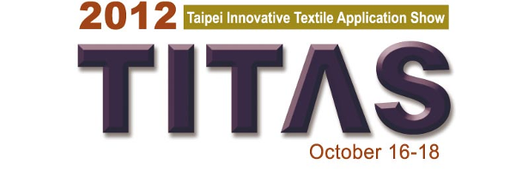

Exhibits Selection Guide for the Trend Forum

Sponsoring Authority: Bureau of Foreign Trade, MOEA
Organizers:
Taiwan Textile Federation (TTF)
Taiwan External Trade Development Council (TAITRA)
Co-Organizers:
Taiwan Textile Research Institute
Industrial Technology Research Institute Union Chemical Laboratories
Foot wear & Recreation Technology Research Institute
Taiwan Association of Machinery Industry and 21 textile-related associations.

Exhibits Selection for Presentation at Trend Forum

- Quantity & Dimensions
- Fabrics (including fabric-type trimmings )
Quantity: 20 – 25
Dimensions: vertical 24" (60cm) x horizontal 16"(40cm)
Notes: Please study the trend directions in Attachment 1 and select your Forum exhibits accordingly.
- Accessories & Trimmings
Quantity: 20 items or a little bit more (button, label, zipper, ribbon…)

- For New Eco & Functional section inside the Trend Forum, please select no more than 5 items of your new functional and eco-friendly fabrics, accessories or trimmings and attach with a short English introduction (50 – 70 words) indicating the new characteristics or advantages for each.

- Please deliver∕airmail your exhibits selection duly labeled (Attachment 3) with the Item List (Attachment 2) to :

Ms. Emily SU
FASHION INSTITUTE OF TAIPEI
No.9, Sec. 2, Xiyuan Rd., Wanhua Dist., Taipei City 108, Taiwan (R.O.C.)
Tel: 886-2-2336-7599 ext.32
Email: trend@textiles.org.tw

The exhibits must reach us before September 20, 2012. For relevant questions, please also contact Ms. Emily SU

- The selection process will be done by TITAS Trend Forum team and preference will be given to new, fashionable exhibits which correspond with our trend directions. TITAS team reserves the right to choose. All the exhibits received will be destroyed after the Show.

Attachment 1
2013/14 A/W Fashion Trend Directions

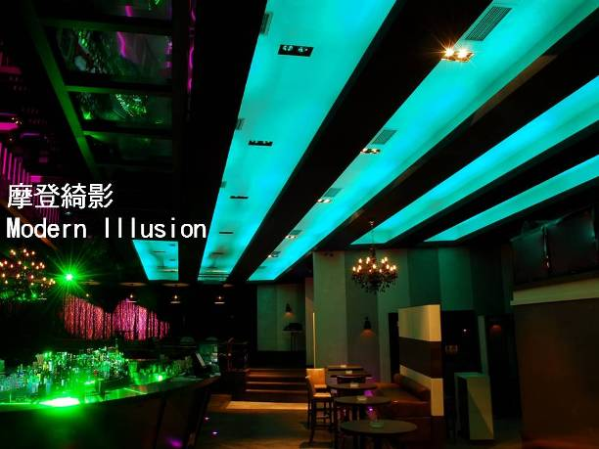

1. Modern Illusion
1-1. Mystery Mood
transplant / Jacquard / print
1-2. Regular Structure
metallics / Lurex / black & white
1-3.Treacherous
imitation leather / structure / mohair

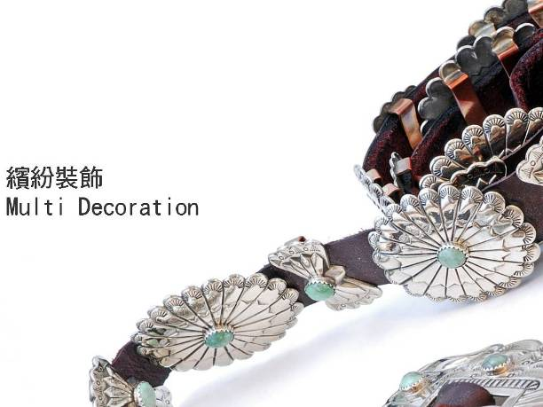

2. Multi Decoration
2-1. Show Off
reflective effect / Lurex / flock print
2-2. Handcraft Boutique
irregular line / contours of plant / dots
2-3. Neo Couture
metallic effect / floral / leather

3. Soft & Urban Look
3-1. Clean & Soft
smooth / light shine / mini textured
3-2. Soft Volume
hairy / quilt / double weave
3-3. Neat Surface
mat / leather look / calendared

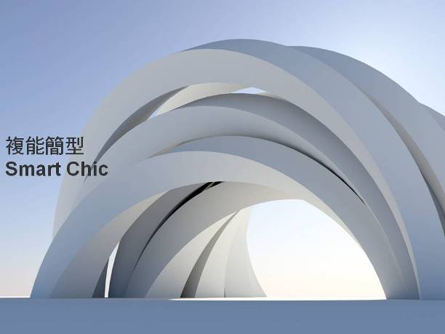

4. Smart Chic
4-1. Shaped & Stiff
felt / high twist / double weave
4-2. constructed Structure
ottoman / rhombus / roving
4-3. Supple & Stretch
double weave / quilt / double knit

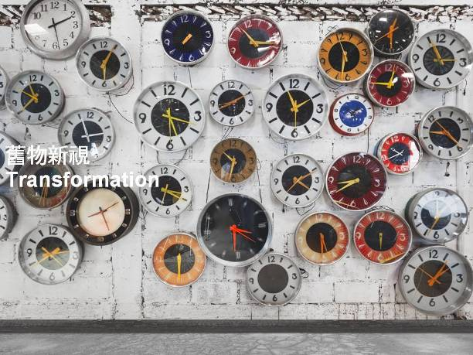

5. Transformation
5-1. Faded New Story
Inlay / cutting / layered
5-2. Poetics Blurred
Jacquard / felt / chine
5-3. Vintage Palace Inspiration
Lurex / overprint / velvet

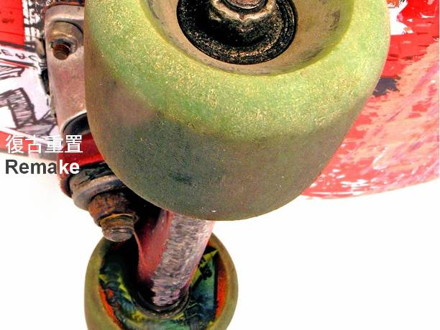

6. Remake
6-1. Faded Double Face
contrast / similar / quilt
6-2. Vintage Look
Jacquard / tweeds / overprint
6-3. Multi-folklore
Embroidery /Jacquard / patchwork

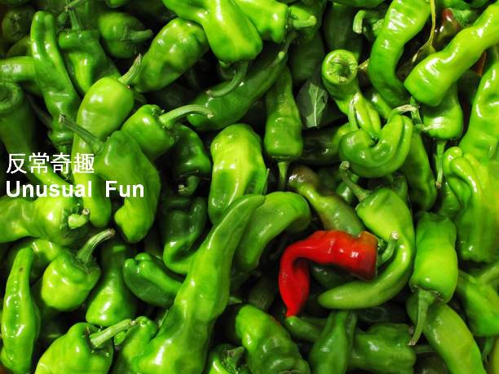

7. Unusual Fun
7-1. Mega Vision
checks & stripes / hairy / structure
7-2. Neo color Felt
semi-plain / fluffy / structured
7-3. Variation Surface
contrast texture / embossed / quilt

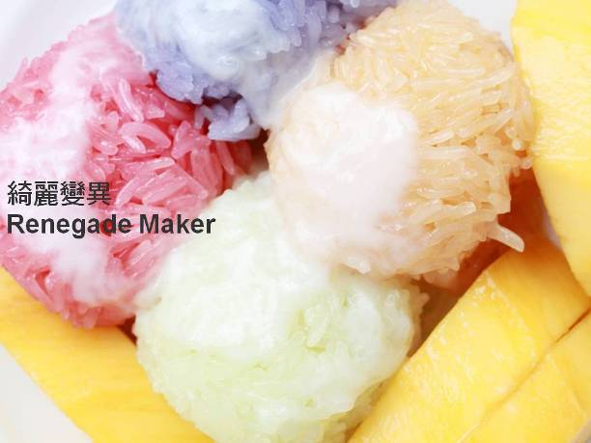

8. Renegade Maker
8-1. Mutation Tweeds
contrasting colors/ 3D effect / roving
8-2. Tangle Surface
fluffy / heterochromatic / rough
8-3. Pretty & Odd
special yarn / Lurex / prints

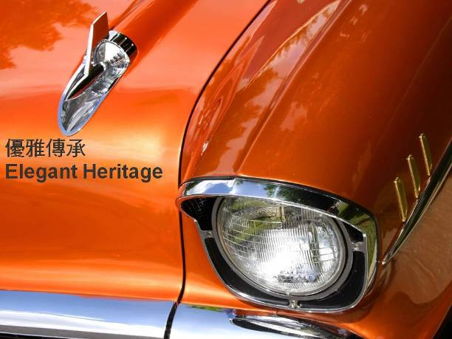

9. Elegant Heritage
9-1. Basic Wovens
twill / plain / georgette
9-2. Monumental Stripes & Checks
tartan / British style checks / zigzag twill
9-3. Traditional Tweeds
twills / dots / checks

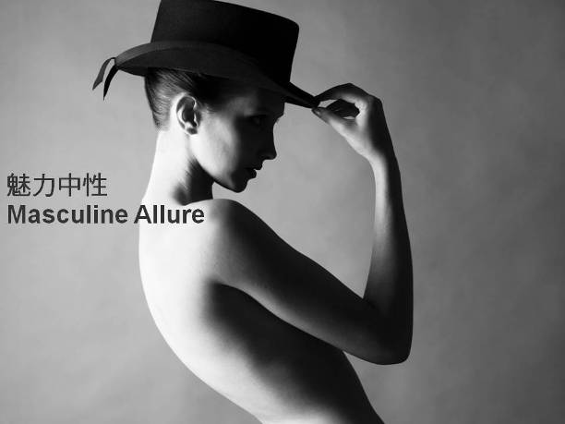

10. Masculine Allure
10-1. Calendered
plains / mini stripes / irregular wovern
10-2. Urban Suitings
Woolen / jacquard / hi-twist
10-3. Modern Geometrics
Shades / stripes / simple patterns

Attachment 2

Exhibits Selection Item List for TITAS 2012 Trend Forum

Please fill in this form in English and send it with your exhibits selection so that we can check it with the exhibits we received, thank you.

Company Name: _____________________________________________

Booth No: _______________

Company Address: ____________________________________________

Contact Person: ____________________ Tel: _____________________

Fax: _____________________________ Email: ___________________

Exhibits selection list:
 | Fabrics | Accessories/  Trimmings | Remarks
example | 8 pcs | Button 10 pcs

Please do not fill in the part below.

Dear _____________,

We have received your exhibits selection on ___________________ and checked it with the list in due course. Thank you.

Taiwan Textile Federation
Attachment 3
Exhibits Label for Trend Forum
(Please fill in one label for one exhibit and adhere it to the lower right corner of your exhibit. Please refer to Attachment 4 for Green∕Gray Label checking if applicable)

Company name: TTF____________ Company name: TTF_____________
Company name: TTF_
Booth no: _____D2001_
Ref no: _____ AA-00000__
Composition: _polyester, cotton_
Function: _UV-cut, anti-bacterial
Label: □Green Label □Gray Label
Company name: TTF_
Booth no: _____D2001_
Ref no: _____ AA-00000__
Composition: _polyester, cotton_
Function: _UV-cut, anti-bacterial
Label: □Green Label □Gray Label
Booth no: _____D2001___________ Booth no: _____D2001___________
Ref no: _____ AA-00000__________ Ref no: _____ AA-00000__________
Composition: _polyester, cotton_____ Composition: _polyester, cotton_____
Function: UV-cut, anti-bacterial____ Function: _UV-cut, anti-bacterial____
Label: □Green Label □Gray Label Label: □Green Label □Gray Label

----------------------------------------------------------------------------------------------------------------
Company name: TTF_
Booth no: _____D2001_
Ref no: _____ AA-00000__
Composition: _polyester, cotton_
Function: _UV-cut, anti-bacterial
Label: □Green Label □Gray Label
Company name: _
Booth no: _____ _
Ref no: _____ __
Composition: _ _
Function: _
Label: □Green Label □Gray Label
Company name: _
Booth no: _____ _
Ref no: _____ __
Composition: _ _
Function: _
Label: □Green Label □Gray Label

-----------------------------------------------------------------------------------------------------------------
Company name: _
Booth no: _____ _
Ref no: _____ __
Composition: _ _
Function: _
Label: □Green Label □Gray Label
Company name: _
Booth no: _____ _
Ref no: _____ __
Composition: _ _
Function: _
Label: □Green Label □Gray Label

-----------------------------------------------------------------------------------------------------------------
Company name: _
Booth no: _____ _
Ref no: _____ __
Composition: _ _
Function: _
Label: □Green Label □Gray Label
Company name: _
Booth no: _____ _
Ref no: _____ __
Composition: _ _
Function: _
Label: □Green Label □Gray Label

Please make extra photocopy when needed.
Attachment 4

Green∕Gray Label Description for Eco-Friendly Textiles
